| **Program Information** | ***[Lesson Title]***  ***Voter Turnout*** | | | | | | **TEACHER NAME**  **Judy Franks** | | | **PROGRAM NAME**  **Ohio Literacy Resource Center** | |
| --- | --- | --- | --- | --- | --- | --- | --- | --- | --- | --- | --- |
| ***[Unit Title]***  **Voting Rights** | | | | | | **NRS EFL**  **2 – 4** | | | **TIME FRAME**  **60 – 180 minutes** | |
| **Instruction** | [**ABE/ASE Standards – Mathematics**](https://www.ohiohighered.org/sites/ohiohighered.org/files/uploads/able/reference/standards/FY15%20CCRs-Ohio%20ABE%20ASE%20Standards.pdf) | | | | | | | | | | |
| **Numbers (N)** | | | | **Algebra (A)** | | **Geometry (G)** | | | **Data (D)** | |
| Numbers and Operation | | |  | Operations and Algebraic Thinking |  | Geometric Shapes and Figures | |  | Measurement and Data | **D.2.5**  **D.2.4** |
| The Number System | | |  | Expressions and Equations |  | Congruence | |  | Statistics and Probability |  |
| Ratios and Proportional Relationships | | | **N.4.9**  **N.4.12** | Functions |  | Similarity, Right Triangles. And Trigonometry | |  |  | |
| Number and Quantity | |  | |  | | Geometric Measurement and Dimensions | |  |
| ***Benchmarks identified in RED are priority benchmarks. To view a complete list of priority benchmarks and related Ohio Aspire lesson plans, please see the***[***Curriculum Alignments***](https://ohioaspire.org/I-Standards.html)***located on the***[***Instructional Resource Collection (IRC)***](https://ohioaspire.org/irc/)***.*** | | | | | | Modeling with Geometry | |  |
| **Mathematical Practices (MP)** | | | | | | | | | | |
| **⌧** | Make sense of problems and persevere in solving them. (MP.1) | | | | | **⌧** | Use appropriate tools strategically. (MP.5) | | | |
| **⌧** | Reason abstractly and quantitatively. (MP.2) | | | | | **⌧** | Attend to precision. (MP.6) | | | |
| **□** | Construct viable arguments and critique the reasoning of others. (MP.3) | | | | | **⌧** | Look for and make use of structure. (MP.7) | | | |
| **⌧** | Model with mathematics. (MP.4) | | | | | **□** | Look for and express regularity in repeated reasoning. (MP.8) | | | |
| **LEARNER OUTCOME(S)**   * The student will gather data about the 2012 presidential election results, then construct a graph to illustrate the data and predict/calculate the outcome of the election based on selected changes in voting patterns. | | | | | | **ASSESSMENT TOOLS/METHODS**   * *Analyze and Graph the Vote* Worksheet * Teacher Observation and Anecdotal Notes | | | | |
| **LEARNER PRIOR KNOWLEDGE**   * Why don’t people vote? Use *2016 Presidential Election -* *Reasons for Not Voting* or *Reported Reasons for Not Voting in the 2014 Elections* to lead a discussion. What conclusions can we draw from these charts? What do your students know about reading charts and graphs? * Based on standardized and informal assessments, students may need extra practice to increase graphing skills development. * Basic understanding of percentages. | | | | | | | | | | |
| **INSTRUCTIONAL ACTIVITIES**   1. Introduce the *Voter Turnout Charts*. Study the first graph. Ask for volunteers to explain how to read a graph. Extract facts from the graph in the form of simple sentences and have students write down several sentences, such as “Ohio’s voter turnout in 2020 increased 3.9% from an estimated voter-eligible population turnout of 65-70%.” Have individuals share their sentences.   Go through the other graphs in the same way. Get everyone to participate in determining the facts the graphs illustrate. When students share the sentences they wrote, ask them to explain why they thought those particular facts were important.  Lead a general discussion using these questions: What are these graphs about? What does this data tell you? What story do these graphs tell? For each graph: Are you surprised to see how the different groups compare? Why do you think some groups are so unlikely to vote? Which of these groups have the least power in the political process? Does this seem fair to you?   1. Show chart and read quote from [Voter turnout rates* among selected age groups in U.S. presidential elections from 1964 to 2020](https://www.statista.com/statistics/1096299/voter-turnout-presidential-elections-by-age-historical/)   “Since 1964, voter turnout rates in U.S. presidential elections have generally fluctuated across all age groups, falling to a national low in 1996, before rising again in the past two decades. Since 1988, there has been a direct correlation with voter participation and age, as people become more likely to vote as they get older. Participation among eligible voters under the age of 25 is the lowest of all age groups, and in the 1996 and 2000 elections, fewer than one third of eligible voters under the age of 25 participated, compared with more than two thirds of voters over 65 years.”   1. Also, state breakdowns of Voter Registration and Turnout Statistics are available from some of the sites mentioned in the resources. The [Voter Turnout in Presidential Elections](https://ballotpedia.org/Voter_turnout_in_presidential_elections,_1840-2020) lists the voting percentages of the adult population back to 1840.   Have students examine the statistics and then discuss with a partner ideas why voter participation has decreased - each pair should record their theories. Give enough time for students to come up with several thoughtful ideas, then have partnerships share their thinking with the class. Ideas will vary, but may include theories such as people don't care about politics, people are too busy to study election issues, people are physically unable to get to the polls, etc. Construct charts together to organize the data.   1. Also, examine historical data and create a chart from the handout *Ohio General Elections 1984-2023 Data Sheet.* What themes are important to share in a visual format? What kind of graph is best for this information?   A typical Census Bureau visualizationis a visual presentation of data made with charts, tables, maps, and other graphic elements. Visualizationsare often interactive and contain text for labeling, but do not have the narrative text of infographics. Like infographics, they are effective because they simplify information and make use of the human ability to see patterns and trends. Students choose one of the visualizations from [Voting and Registration Visualizations](https://www.census.gov/topics/public-sector/voting/library/visualizations.html) and write a narrative to explain the visual.     1. What is voting like in your community? Have students use the [United States Census Bureau](https://www.census.gov/topics/public-sector/voting.html) website to research local voting statistics and trends, noting who tends to vote and who doesn't, voting percentages in community districts, etc. Instruct students to analyze the data to identify voting patterns, in particular, among groups of people who typically do not vote. Students might want to contact community organizations, advocates, and others who represent these populations to speak as panelists at a school- and/or community-based forum on the issue of under-representation in voting among these groups. Students could then work with these groups to increase participation, or alternatively, students could write press releases highlighting participation trends, speaking to their implications. 2. When students are ready, have them complete the *Analyze and Graph the Vote* independently. The website [Suburban Stats](https://suburbanstats.org/population/how-many-people-live-in-ohio) is a good source of data on the states. Use data with current population to predict election outcome. Use a calculator when necessary and make sure to check if work seems reasonable.   Additional Ideas/Extensions:   1. Help students register to vote. 2. Graph [election data](https://www.politico.com/2020-election/results/) from eastern states, neighboring states, counties in Ohio, or different parts of Ohio. 3. Graph the voting percentages in presidential elections found in the [Voter Turnout in Presidential Elections.](http://www.presidency.ucsb.edu/data/turnout.php) 4. Using the website [2024 Presidential Election Interactive Map](https://www.270towin.com/) compare the differences in the electoral vote and popular vote between the winners and losers. 5. Write ratios using the election results. | | | | | | **RESOURCES**  Projector, ability to project  *2016 Presidential Election -* *Reasons for Not Voting* (attached)  *Reported Reasons for Not Voting in the 2014 Elections* (attached)  *Voter Turnout Charts* (attached)  Statista. (n.d.). Voter turnout rates* among selected age groups in U.S. presidential elections from 1964 to 2020. Retrieved from https://www.statista.com/statistics/1096299/voter-turnout-presidential-elections-by-age-historical/ Ballotpedia. (n.d.). Voter turnout in presidential elections, 1840-2020. Retrieved from https://ballotpedia.org/Voter_turnout_in_presidential_elections,_1840-2020 U.S. Census Bureau. (2022). Voting and Registration Visualizations. Retrieved from https://www.census.gov/topics/public-sector/voting/library/visualizations.html  U.S. Census Bureau. (2022). Voting and Registration. Retrieved from  https://www.census.gov/topics/public-sector/voting.html Suburban Stats, Inc. (2019).Current Population Demographics and Statistics for Ohio by age, gender and race. Retrieved from https://suburbanstats.org/population/how-many-people-live-in-ohio Student copies of *Ohio General Elections 1984-2023 Data Sheet* (attached)  Student copies of *Analyze and Graph the Vote* (attached)  Calculators for student use | | | | |
| **Reflection** | **DIFFERENTIATION**   * Students can complete the entire lesson with a partner. * Complete calculations on *Analyze and Graph Data* using whole numbers. * If necessary, provide assistance calculating percentages in questions 3b and 3c and setting up the scale on the graphs developed. * Upper-level students can use the data in the chart "Reasons for Not Voting" to construct a circle or 100% graph. | | | | | | | | | | |
| **TEACHER REFLECTION/LESSON EVALUATION**  There are lots of great opportunities for ELA practice on the topic of voting. Students will practice reading graphs in Social Studies with this lesson. | | | | | | | | | | |
| **ADDITIONAL INFORMATION**   * Have the students select an additional state to use to complete the *Analyze and Graph Data* Handout. Use the data from the last election and calculate what percentage of change in votes would be required to change the outcome. * Ask the student to graph election results based on demographics (e.g., age group, sex, race, religious preference). * Have the student create several different graphs and discuss how easy they are to interpret * Students can practice graphing and understanding voting rates at the Voter Turnout Learning Objects. | | | | | | | | | | |

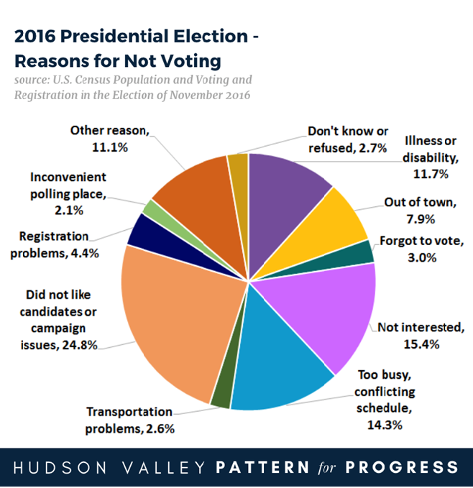

Source: https://www.pattern-for-progress.org/wp-content/uploads/2020/11/Pattern-Data-Reasons-for-not-voting.png

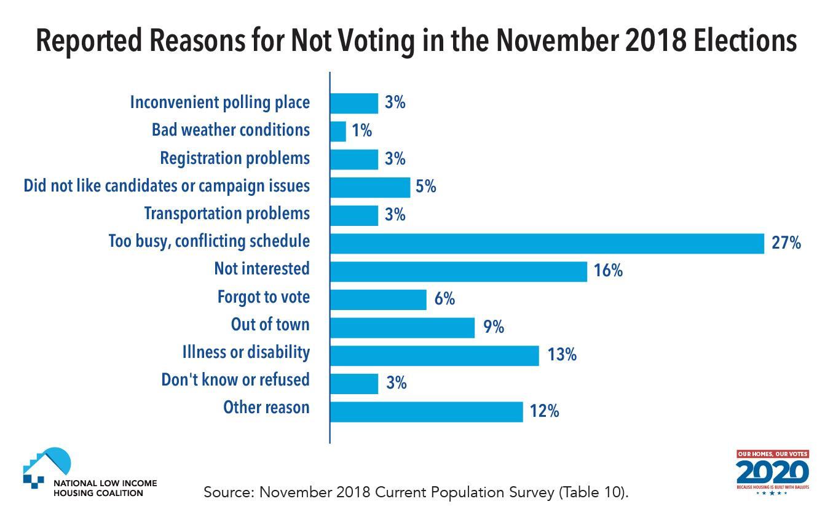

https://nlihc.org/sites/default/files/OHOVotes/reasons_for_not_voting_web.jpg

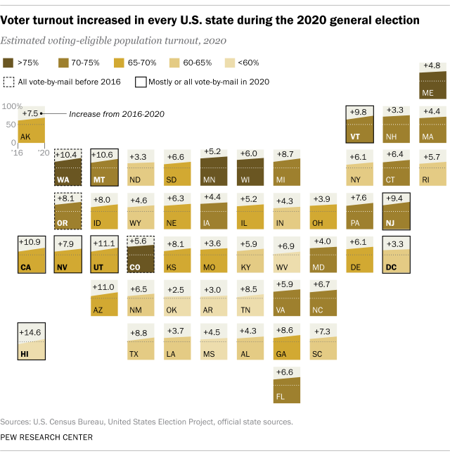

Source: https://www.pewresearch.org/wp-content/uploads/2021/01/FT_21.01.19_2020Turnout_2a.png?w=640

**Voter Turnout Charts**

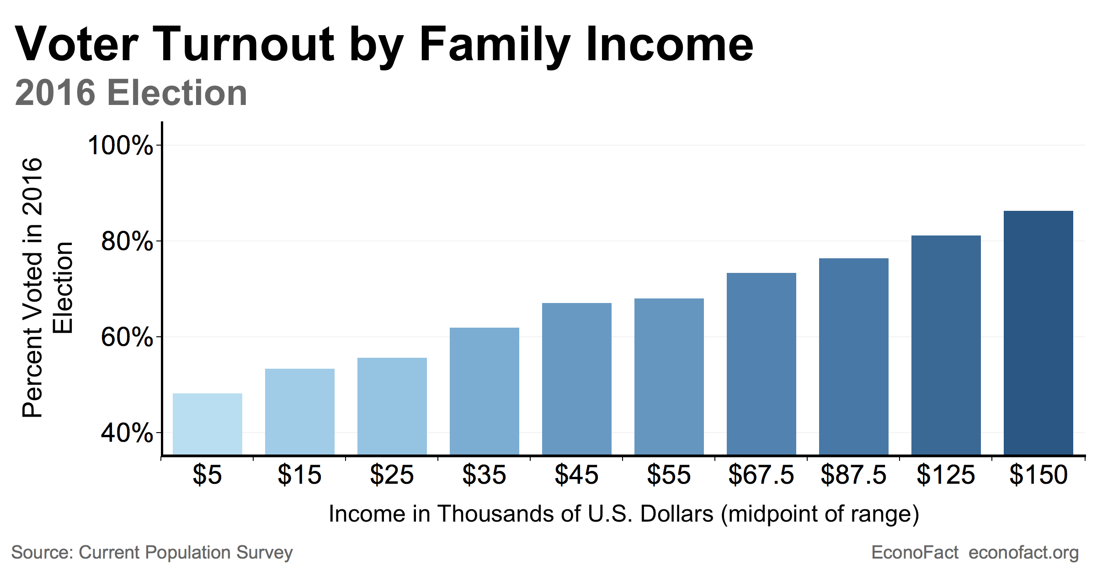

Source: https://econofact.org/wp-content/uploads/2019/02/Voting-income-chart-social-final.png

**Voter Turnout Charts**

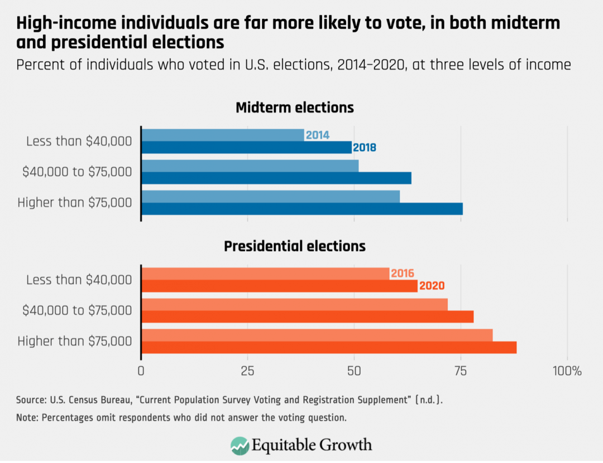

Source: https://equitablegrowth.org/wp-content/uploads/2021/07/High-income-individuals-are-far-more-likely-to-vote-in-both-midterm-and-presidential-elections-1080x831.png

**Voter Turnout Charts**

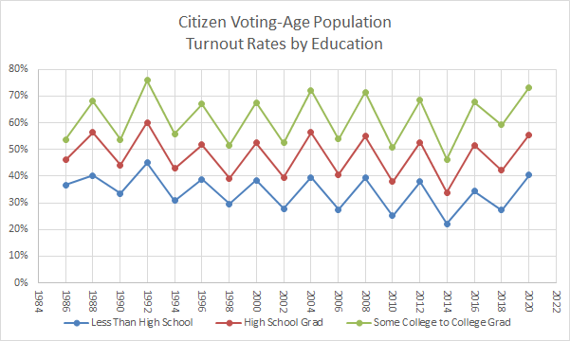

Source: https://slcc.pressbooks.pub/app/uploads/sites/11/2022/11/Voter-Turnout-Education-2020.png

**Voter Turnout Charts**

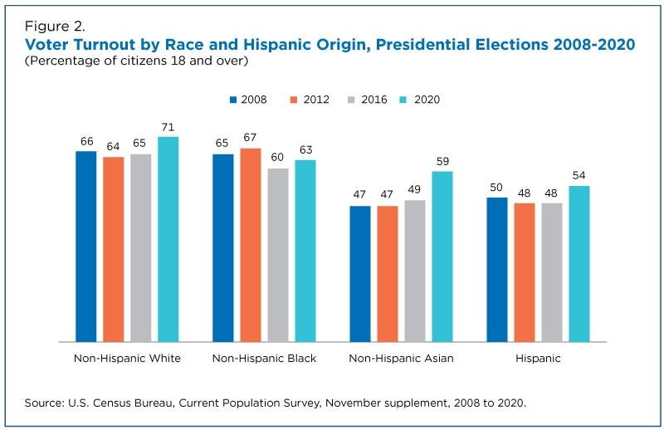

Source: https://www.census.gov/content/dam/Census/library/stories/2021/04/record-high-turnout-in-2020- general-election-figure-2.jpg

**Voter Turnout Charts**

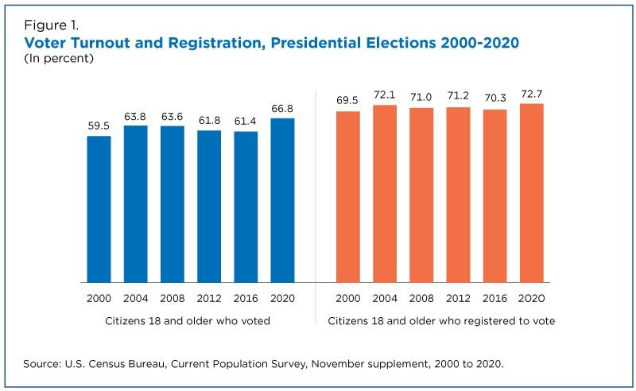

Source: https://www.census.gov/library/stories/2021/04/record-high-turnout-in-2020-general-election.html

**Voter Turnout Charts**

[**Ohio General Elections 1984-2023 Data Sheet**](https://www.ohiosos.gov/elections/election-results-and-data/historical-election-comparisons/voter-turnout-in-general-elections/)

**Election Year Registered Voters Electors Voting Percent Voting**

1984 6,332,454 4,664,223 73.66%

1985 6,082,980 2,564,623 42.16%

1986 5,996,430 3,261,870 54.40%

1987 5,822,189 2,759,276 47.39%

1988 6,275,638 4,505,284 71.79%

1989 5,830,757 2,840,926 48.7%

1990 5,912,746 3,620,469 61.23%

1991 5,820,133 2,983,565 51.26%

1992 6,536,936 5,043,094 77.14%

1993 6,204,103 2,815,567 45.38%

1994 6,231,724 3,570,391 57.29%

1995 6,416,133 2,774,300 43.35%

1996 6,879,687 4,638,108 67.41%

1997 7,022,866 3,128,446 44.54%

1998 7,096,423 3,534,782 49.81%

1999 7,146,985 2,467,736 34.53%

2000 7,531,555 4,800,009 63.73%

2001 7,153,796 2,574,915 35.99%

2002 7,113,826 3,356,258 47.81%

2003 7,138,932 2,614,354 36.62%

2004 7,972,826 5,722,443 71.77%

2005 7,684,320 3,093,968 40.26%

2006 7,860,052 4,184,072 53.23%

2007 7,772,654 2,436,070 31.34%

2008 8,287,665 5,773,777 69.97%

2009 8,041,612 3,292,374 44.64%

2010 8,037,806 3,956,045 49.22%

2011 7,709,478 3,628,342 47.06%

2012 7,987,203 5,633,246 70.53%

2013 7,702,189 2,077,619 26.97%

2014 7,748,201 3,149,876 40.65%

2015 7,529,667 3,255,537 43.24%

2016 7,861,025 5,607,641 71.33%

2017 7,906,818 2,395,090 30.29%

2018 8,070,917 4,496,834 55.72%

2019 N/A N/A N/A

2020 8,073,829 5,974,121 73.99%

2021 N/A N/A N/A

2022 8,029,950 4,201,368 52.32%

2023 7,988,132 3,964,530 49.63%

**Additional Resource** Ohio Historical Election Data [**http://www.sos.state.oh.us/sos/elections/Research/electResultsMain.aspx**](http://www.sos.state.oh.us/sos/elections/Research/electResultsMain.aspx)

**ANALYZE AND GRAPH THE VOTE**

Use the 2020 Presidential election data for Ohio <https://www.politico.com/2020-election/results/ohio/> to answer the following.

1. Find the 2020 presidential election results for Ohio by political party. How many ways can you report this data? Why did you choose to report the data in the way you did?
2. Use the state election data to construct a graph of your choice (bar, circle, line, or pictograph).
3. Analyze the graph and data to answer the following questions and make predictions.
4. How many more votes did the Demoncratic candidate need to win Ohio?
5. What percentage of the total votes would this be?
6. If the state kept the same percentage of voters as in the 2020 election for each candidate, what would be the number of voters for each candidate using the current Ohio population?
7. If all voters who voted for an alternative party candidate switched their votes to the Democratic candidate, would Ohio's electoral votes have been awarded to a different candidate?
8. How do the election results in your home county compare to the Ohio results?



[**http://www.wisconline.org**](http://www.wisconline.org)

**Line Graphs**

**Author:** Barbara Laedtke  
**School:** Fox Valley Technical College **Date:** 9/16/2002  
**Description:** Learners read an explanation of line graphs and demonstrate their knowledge of the parts of a graph in an interactive exercise.   
<http://www.wisc-online.com/objects/index_tj.asp?objID=SOC302>

**Interpreting Line Graphs**

**Author:** Barbara Laedtke  
**School:** Fox Valley Technical College **Date:** 4/19/2002  
**Description:** Students analyze line graphs and answer questions about the information shown.   
<http://www.wisc-online.com/objects/index_tj.asp?objID=SOC702>

**Reading and Interpreting Bar Graphs**

**Author:** Francine Nettesheim  
**School:** NorthcentralTechnical College **Date:** 7/10/2002  
**Description:** Students identify the various parts of a bar graph, read and interpret data presented in a bar graph, and calculate the data to solve various application problems.  
<http://www.wisc-online.com/objects/index_tj.asp?objID=ABM3802>

**Understanding Voting Rates**

**Author:** Barbara Laedtke  
**School:** Fox Valley Technical College **Date:** 8/4/2005  
**Description:** Students examine how voting rates are determined and how those rates change depending upon the population being studied. A brief quiz completes the activity.   
<http://www.wisc-online.com/objects/index_tj.asp?objID=SOC6005>

**Voter Turnout Learning Objects**